Graduate Directed Project

User Requirements Document

Version 1.0.0, 1st October 2014

Farming UAV Image Analysis

And Robotics

|  |  |  |
| --- | --- | --- |
| **Project Team:** | Murali Krishna | S519431 |
|  | Naveen Kumar Reddy | S519381 |
|  | Pragna Choudari | S519298 |
|  | Harshavardhan Naidu | S519483 |
|  | Priyanka Peddi | S519408 |
|  | Naveen Poreddy | S519472 |
|  | Sai Srujan | S519471 |
|  | Akhilesh Reddy | S519391 |
|  | Varun Chintalapuri | S519462 |
|  | Vamsi Krishna | S519407 |

**Project Client:** Dale Dickkut

**Project Mentor:** Dr. Wei Xiong

**Project Committee:** Dr. Carolyn Hardy

**Database Committee:** Dr.Merry McDonald

Abstract

This document contains the user requirements for the Farming UAV Image Analysis and Robotics system. This is a graduate directed project (44-696) at Northwest Missouri State University.

These user requirements were established according to requests formulated by the Client Dale Dickkut. The document complies with the User Requirements Document (URD) from the Software Engineering Standards.

# Contents

1. **Introduction 1**
   1. Purpose ………………………………………………………………….……………………………………………………..1
   2. Scope ………………………………………………………………………………………………………………………...1
   3. Product Context …………………………………………………………………………………………………………..1
   4. List of definitions and abbreviation ……………………………………………………………………………….1
      1. Definitions ……………………………………………………………………………………………………………….1
      2. Abbreviations ………………………………………………………………………………………………………….2
   5. References ……………………………………………………………………………………………………………………2
   6. Overview ………………………………………………………………………………………………………………………3
2. **Functional Requirements 4**
   1. User Login ……………………………………………………………………………………………………………………..5
   2. Inputting Image ………………………………………………………………………………………………………5
   3. Image Analysis ……………………………………………………………………………………………………..5
   4. General Constraints ………………………………………………………………………………………………………6
   5. Trust model …………………………………………………………………………………………………………………..6
3. **User Characteristics**………………………………………………………………………………………………………….6
4. **Prototypes**……………………………………………………………………………………………………………………….**.7**

**5 Future Enhancements** ……………………………………………………………………………………………………....12

Document Status Sheet:

|  |  |  |  |  |  |  |  |  |  |  |  |  |  |
| --- | --- | --- | --- | --- | --- | --- | --- | --- | --- | --- | --- | --- | --- |
|  | Document Title | | |  |  | User Requirements Document | | | | |  |  |  |
|  | Document Identification | | | |  | Farm UAV/Documents/Product/URD/1.0.0 | | | | | | |  |
|  | Author(s) | |  |  |  | Akhilesh Reddy Muthyampeta, Sai Srujan Nallamekala, | | | | | | |  |
|  |  | |  |  |  | Varun Reddy Chintalapuri, Naveen Reddy Poreddy, Vamsi Krishna Pedamallu | | | | | | |  |
|  |  |  |  |  |  |  |  |  |  |  |  |  |  |
|  | Version | |  |  |  | 1.0.0 |  |  |  |  |  |  |  |
|  | Document Status | | |  |  | Draft | | | | | | |  |
|  |  |  |  |  |  |  | | | |  |  |  |  |
|  | Version |  |  |  | | |  |  |  |  | |  |  |
|  | Version |  | Date | Author(s) | | |  |  |  | Summary | |  |  |
|  | 1.0.0 |  | 10-01-2014 | Akhilesh, Sai Srujan | | |  | | | Document creation | | | |
|  |  |  |  |  |  |  |  |  |  |  |  |  |  |

# Document Change Report:

|  |  |
| --- | --- |
| Document Title | User Requirements Document |
| Document Identification | Farming UAV/Documents/Product/URD/1.0.0 |
| Section Number |  |
| Reason for Change |  |
| Date of Changes |  |

**Chapter 1**

# Introduction

## 1.1 Purpose

The purpose of this document is to specify the requirements of Farming UAV image analysis and robotics in a clear and consistent manner.

## 1.2 Scope

This is a stand-alone application which intakes the scanned farm image as input and does the job of analyzing the picture to provide the details related to crop health at a particular location in the crop. This application would be of useful for farmers who cultivate in large fields. Usability is also increased by offering a front-end for users to access the system.

## 1.3 Product Context

At present the farms are scanned using a drone machine which takes multiple NIR images of the crop. These obtained images from the drone are stitched together to provide in one piece image (Figure 1) of the farm. Later using the NDVI values upon image the health information of the farm on whole is obtained as in figure 2. Our goal in this project is to use the NIR image in figure 1, NDVI range and position coordinates of the image to obtain the health of crop as explained in section 2.3.



Figure 1

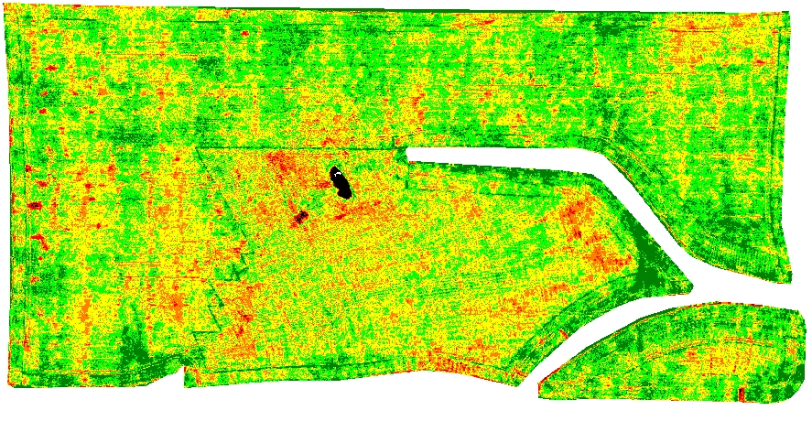

Figure 2

## 1.4 List of definitions and abbreviations

## 1.4.1 Definitions

|  |  |
| --- | --- |
| Application | A non-interactive data processing application consisting of executables, scripts and/or auxiliary data files that reads one or more input data files and writes one or more output files. |
| Job | Computation of location coordinates, determining the crop health by dividing the picture into several blocks and finding the average of particular color pixels in each block. |
| Image Analysis | Process of extracting meaningful information from images; mainly from digital images by means of digital image processing techniques. |

### 1.4.2 Abbreviations

|  |  |
| --- | --- |
| UAV | Unmanned Aerial Vehicle |
| URD | User Requirements Document |
| GPS | Global Positioning System |
| NIR | Near Infrared Reflectance |
| NDVI | Normalized Difference Vegetation Index |

|  |  |
| --- | --- |
| **1.5** | **References** |
| RD1 | E-mail from Monismith David, ”Farming UAV image analysis and robotics User Requirements”, August 21 2014 |
| RD2 | Client meeting, September 3 2014 |
| RD3 | E-mail from Dale Dickutt,”Coordinates of GPS drawings”, September 12 2014 |
| RD4 | Client meeting, September 26 2014 |
| **1.6** | **Overview** |

This document is structured from the requirements gathered during in [RD 1][RD 2][RD 4].

Chapter 2 gives the description of functional requirements of the application. It describes the product, the capabilities and the characteristics of the users and the environments it is going to operate in.

Chapter 3 describes a set of use cases.

Chapter 4 describes specific requirements for Farm UAV image Analysis and Robotics.

**Chapter 2**

# Functional Requirements

## 2.1 Application Security:

The application verifies the authenticity of the user by providing login and password fields. User would be able to use the application only when the login details are valid. There is also an option to change the existing password of the user which would be done by answering the security questions.

## 2.2 Inputting Image:

The application allows the user to submit one image at a time.

User has to provide the image information which includes:

**Name of the image:** name of the input image will be typed in this field by user

**Image URL:** the user provides the link of the image which he can browse from the desktop

**Total Area:** Inputs the total area of the field

**Width in Feets:** Inputs the breadth of the field

**Height in Feets:** Inputs the height of the field

**Longitude:** User inputs the longitude position of any four corners of the overall field

**Latitude:** User inputs the latitude position of any four corners of the overall field

**Split:** Clicking on this button will perform the image analysis.

## 2.3 Image analysis:

Upon taking the UAV drone farm image as input the application performs image analysis to provide the health of crop by dividing the picture into several blocks and finding the average of particular color pixels in each block. This is done as shown in figure below. The original image will be divided into several blocks each sized to a scale of one acre (scale can be variable). Upon hovering or clicking onto a particular grid the application should be able to give crop information which consists the information related to the percentage of a particular color in that block and also the location details through which the health of crop can be known in detail at any block

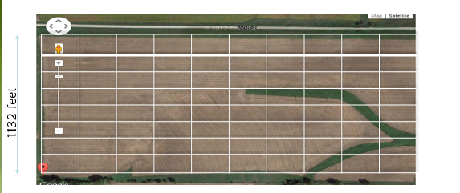.

Grid

## 2.4 General Constraints

The accuracy in calculating the geographic location at a pixel depends upon the scale to which the area has to be considered.

### 2.5 Trust model

The Farm UAV application offers security by providing access restrictions with login credentials. This provides access to only authenticated users.

**Chapter 3**

# User characteristics

### 3.1 Users

There exists only a single role for this application i.e. the end user who can use all the features of the application.

**Application User:** The end user can access the application with login credentials and submit the image as input.

The relationship between the user and application with various actions to be performed is shown in below use case diagram



**Chapter 4**

**Prototypes**

Below are the various tool drawn prototypes showing the user interface of the application

**Login Screens:**

* This is a login screen for the application where user enters his username and password for the application and clicks on ‘Log In’ button to enter into the application.
* Upon clicking ‘login’ user will be directed to screen 2.
* Upon clicking ‘forgot password’ user can change the password by entering old password and new password fields.

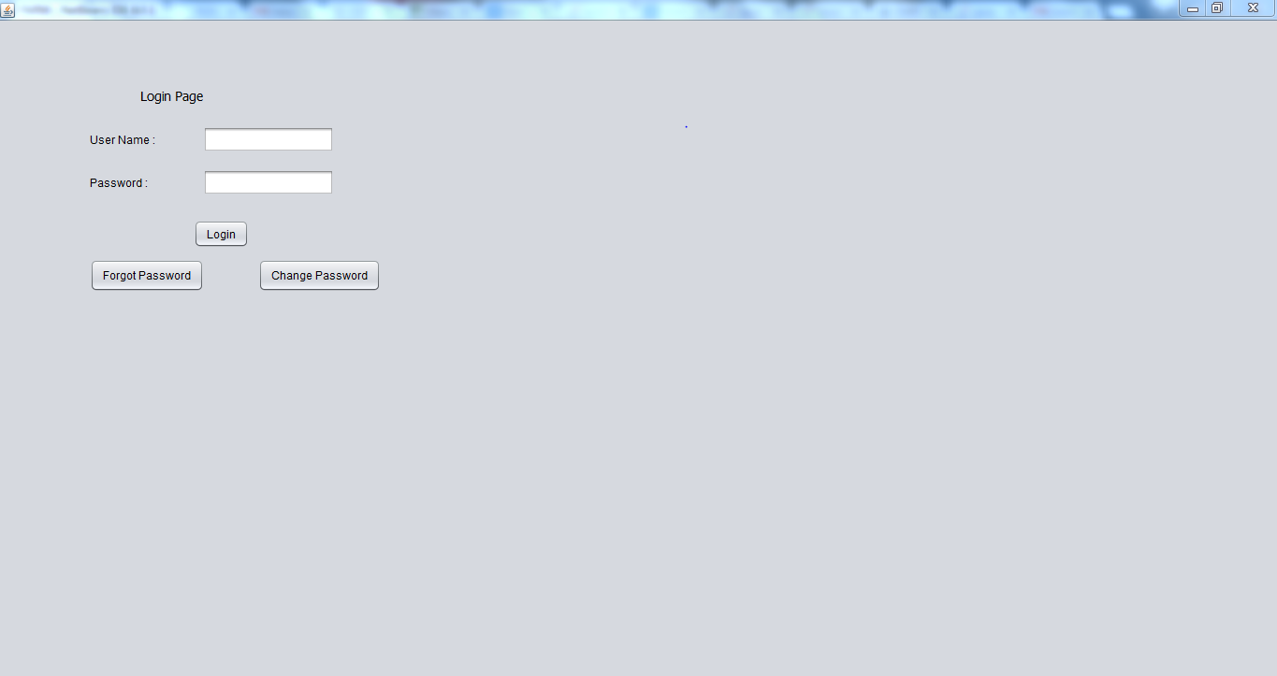

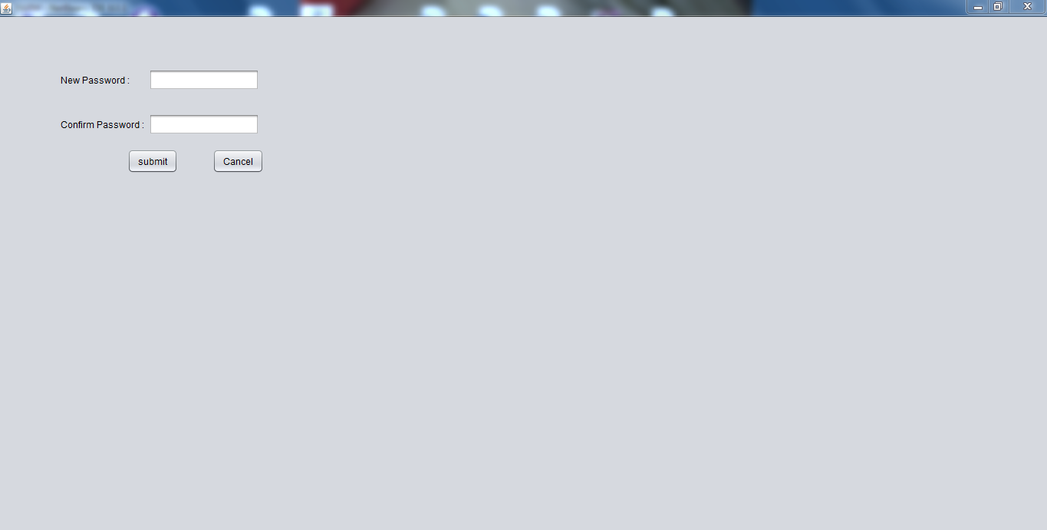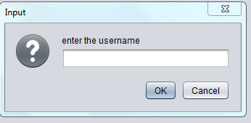

**Security question dialog screens**

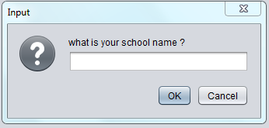 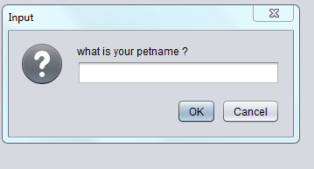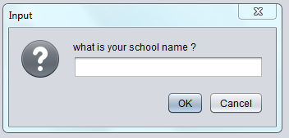 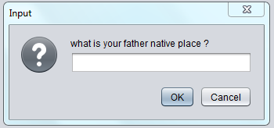

### Analyze/Search Image screen:

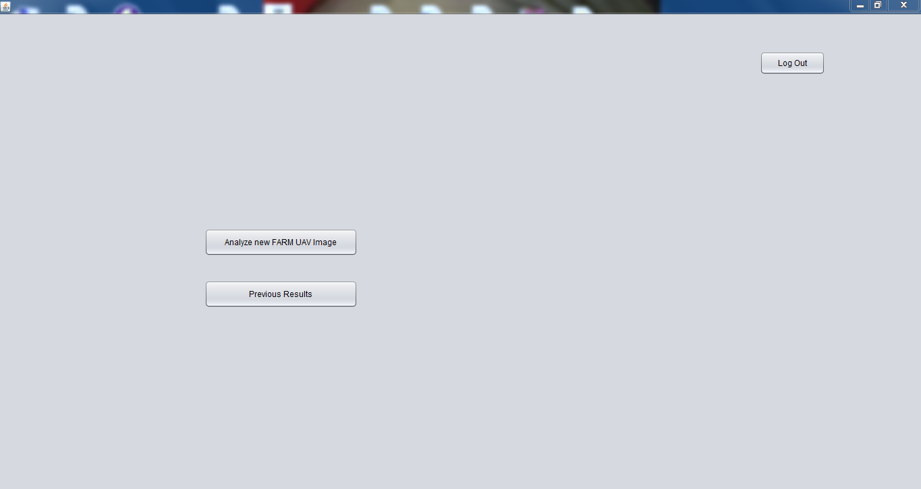

The above screen involves two operations

a) Analyze FARM UAV Image

b) Previous Results

**a) Analyze FARM UAV Image**

Below is the screen where user gives the image as input by clicking on browse button and chooses the file from his desktop.

* **Name of the Image**: User can enter name for the image for future reference.
* **Total Area**: the total field area will be entered into the text field.
* **Width in feets**: User enters the width of the field in feet.
* **Length in feets:** The user enters the height of the field in feet.
* **Longitude:** This field has to be provided with the longitude information of any four corners of the total scanned field.
* **Latitude:** This field has to be provided with the longitude information of any four corners of the total scanned field.
* **Submit for Analyzing image:** Upon clicking submit user will be directed to screen 3.

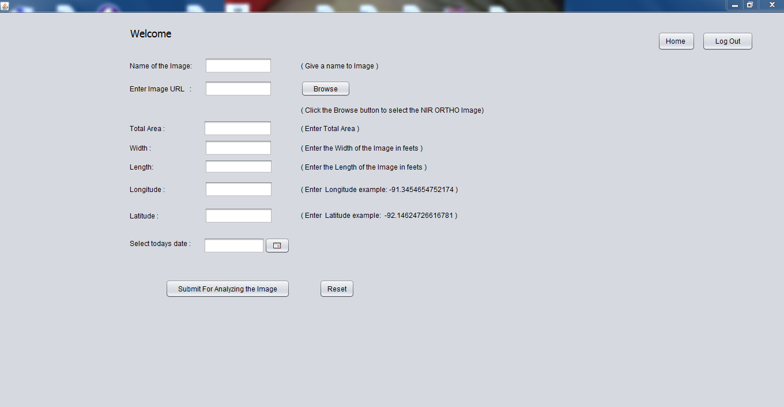

The below screen shows the information obtained after performing the image analysis by application.

* The image is displayed at the left top and a table below that has the summary of color, NDVI and acres. The information can be used to obtain the amount of a particular color in the total field.
* User will be able to save the above tabular data in a file by clicking on ‘Save’ button**.**
* If user wants to get a detailed information at any block he can click on the ‘split’ button which will direct the user to screen 4

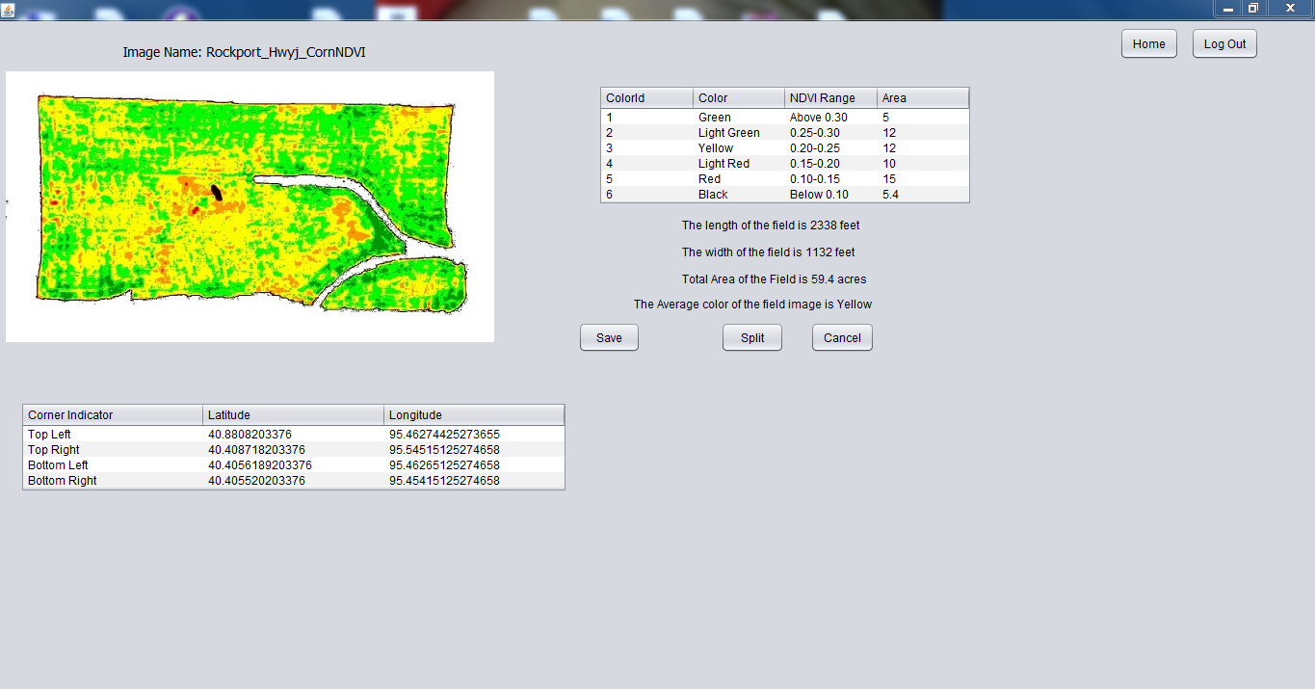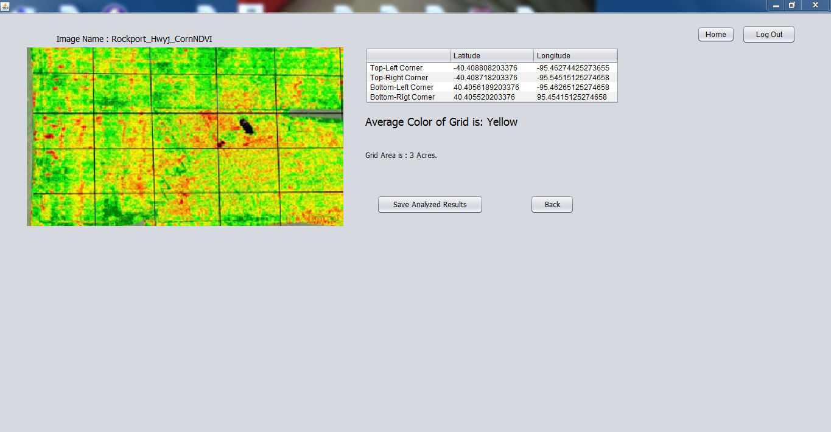

Below screen shows the image divided into several grids when hovered onto a particular grid the application will be able to provide the details related to average color and positioning information.

**Previous Results Screen:**

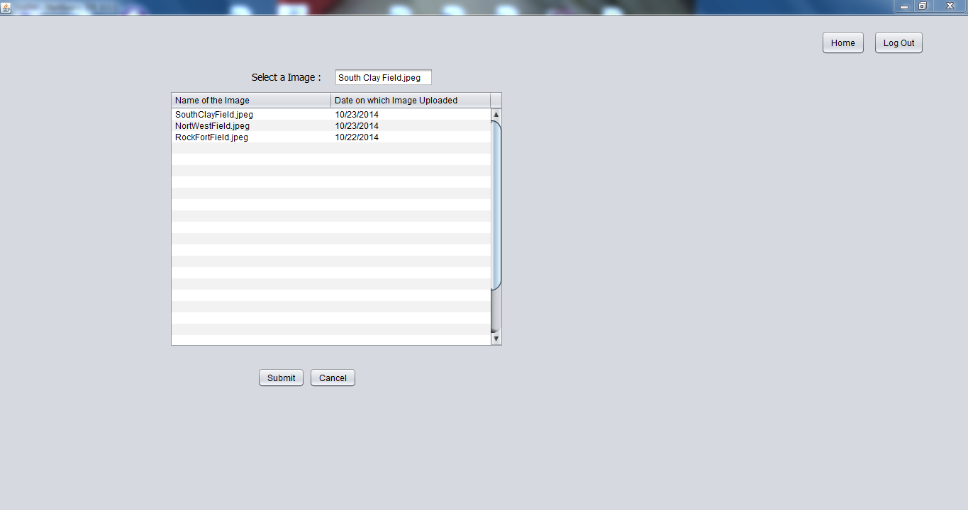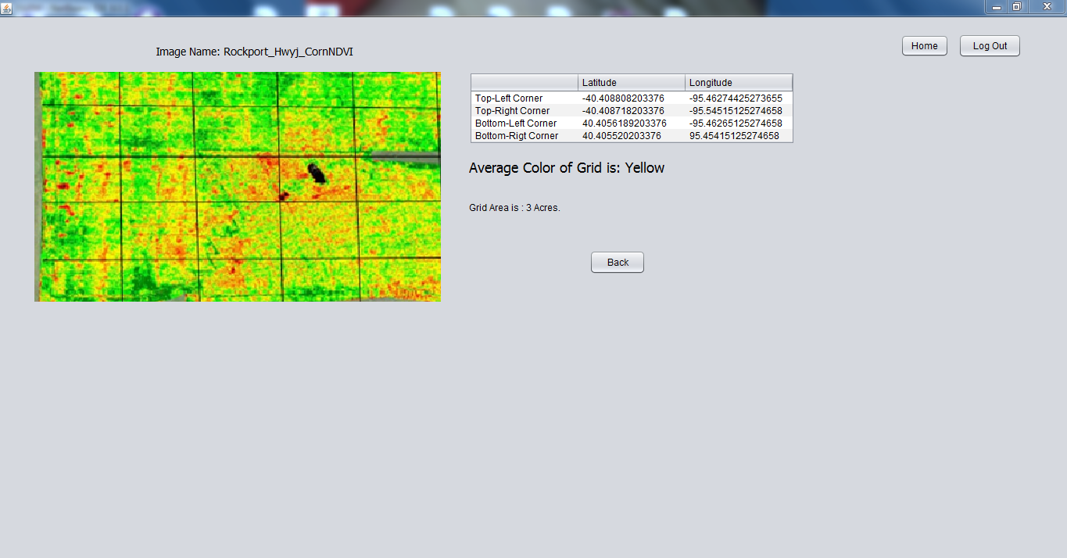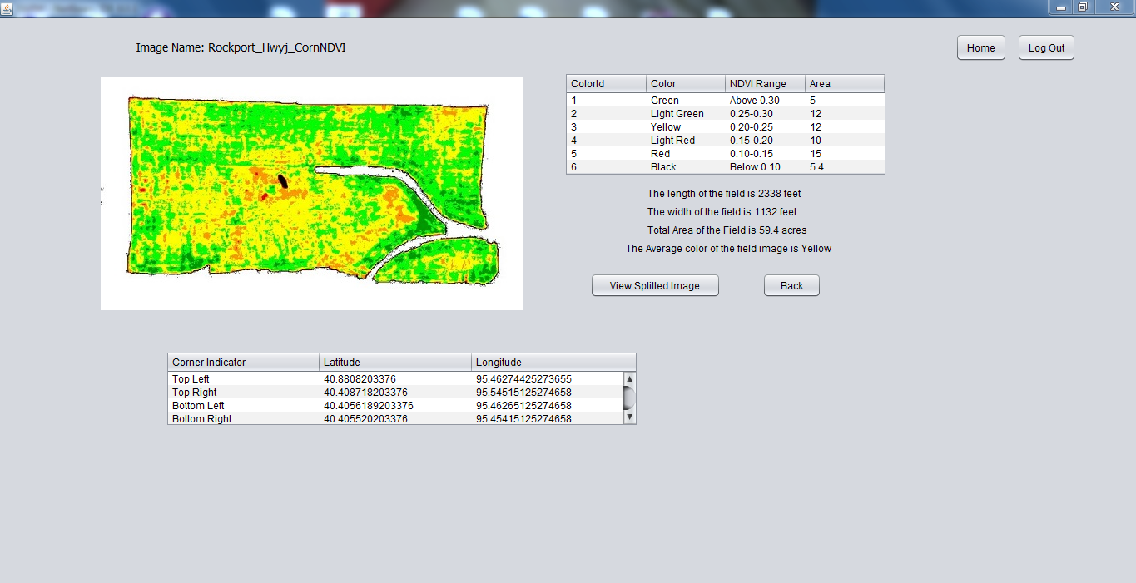

**Chapter 5**

**5 Future Enhancements:**

This application is robust and allows to make changes related to the user interface and the format in which the output is requested. For example, the user can have an output as shown in the above screen or document in a tabular form with each grid information.